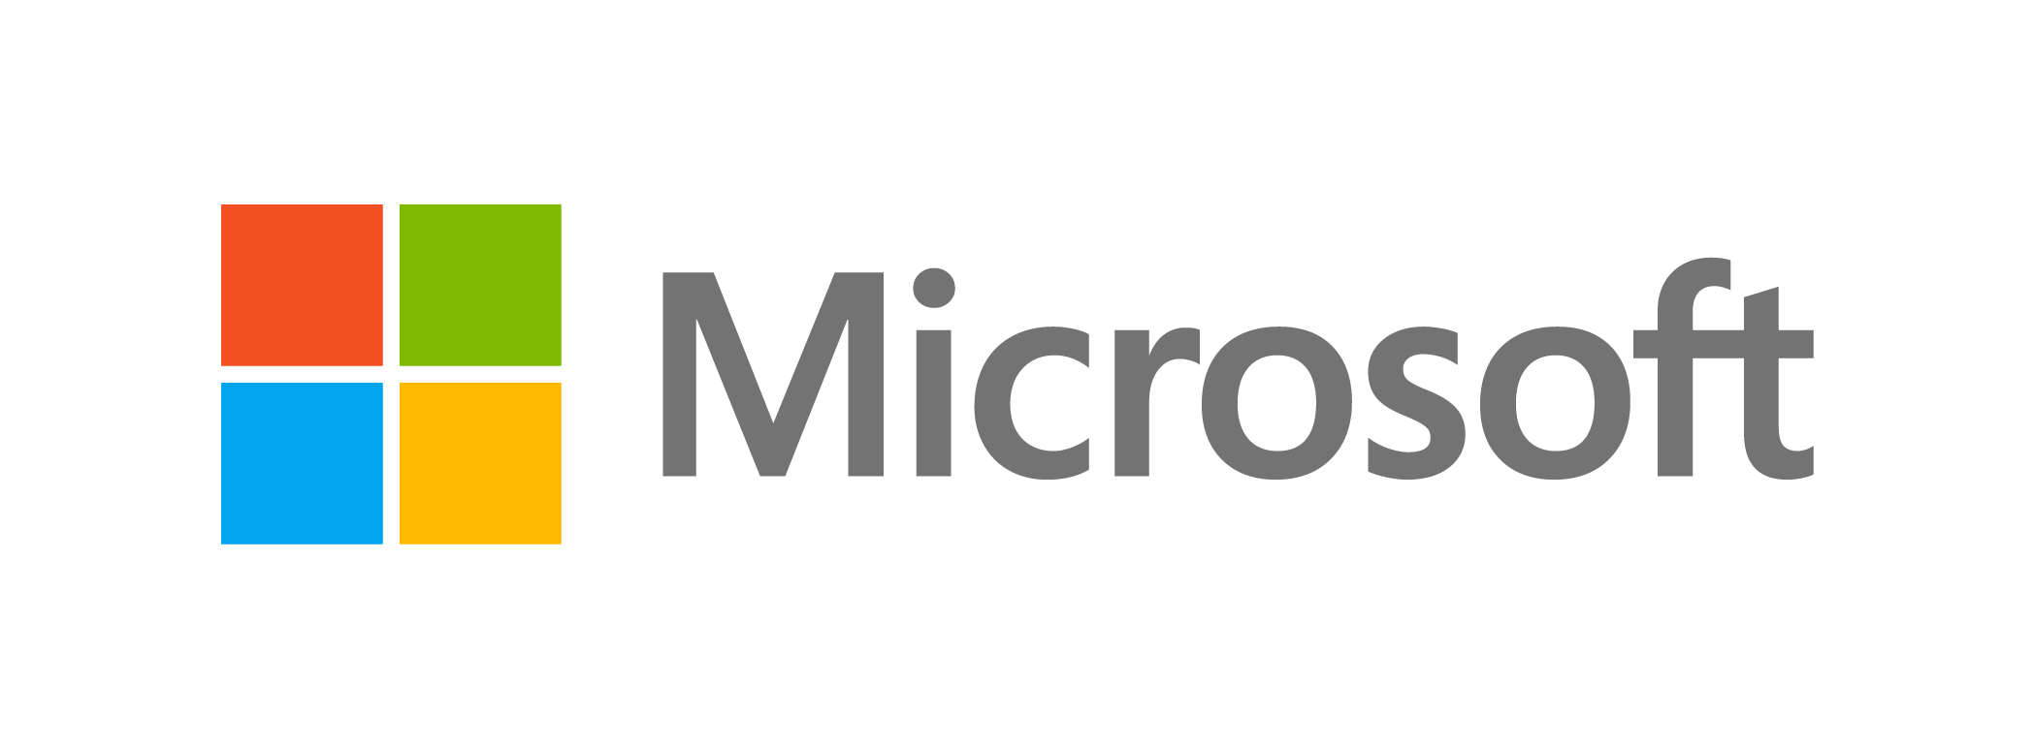November 2015

IT Showcase Productivity Guide

Use Reset to restore your Windows 10 PC

In Windows 10, you can use Reset to restore the operating system on your PC by reinstalling Windows. This lets you restore Windows without using a separate recovery image (usually on a DVD or USB thumb drive) that contains a backup copy of all system files.

Reset restores the PC by reinstalling the original system configuration and then applying Windows updates to get it to the last major update state. Use the **Keep my files** option to preserve user accounts, data, pre-installed Windows apps and applications, and customized settings. The **Remove everything** option restores the PC in the same manner, but without preserving any user accounts, data, or customized settings.

# Topics in this guide include:

Introduction and user benefits

System requirements and installation

Using Reset while Windows is running

Using Reset when Windows will not start

For more information

# Introduction and user benefits

If your Windows 10 PC is not running well, you may want to reset Windows to clean up any problems with settings, problems with applications, or malware.

Reset restores Windows to the most recent release or major update available. Depending on which Reset option you choose (**Keep my files** or **Remove everything**), your data files and customized Windows settings will or will not be removed. Pre-installed Windows applications are preserved, and any customizations to them are restored to their factory state.

Your organization’s IT department may configure Reset so that, in addition to reinstalling Windows 10, it also installs updates that were available after the initial setup of the operating system, up to the last major update. Please check with your IT department.

The **Remove everything** option is the best choice when the PC is changing ownership or being recycled. Use Reset with the **Remove everything** option to restore Windows when you do not want to preserve any user accounts, data, and customized settings.

Note that, by default, Reset will affect only the drive partition on which Windows 10 is installed; however, you can choose to override this if you want to erase additional drive partitions.

## Restoring drivers

Drivers are restored in a similar fashion as the operating system. As with system files, drivers are restored to the most recent release or major update available, which ensures compatibility between drivers and the Windows operating system.

## Restoring user-installed applications

Reset cannot recover applications that were installed by a user after the initial Windows setup.

## Restoring language packs

Language packs that are not used by at least one user account are removed from the Windows Component Store seven days after the Out-of-Box Experience (OOBE). Using Reset after that point will not restore the removed language packs. Conversely, language packs downloaded and installed by users, and used by at least one user account, will be restored during Reset recovery.

# System requirements and installation

Reset is built into the Windows 10 operating system, available through the Start menu (**Settings** > **Update & Security** > **Recovery**). If there is a custom configuration, it is installed silently, so there is no need to run any installation program. If Windows will not start on your PC, the Windows Recovery Environment launches, and you can run Reset from there.

# Using Reset while Windows is running

1. Open the Start menu, then select **Settings**.

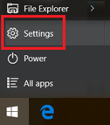

1. Select **UPDATE & SECURITY** > **Recovery > Get started**.

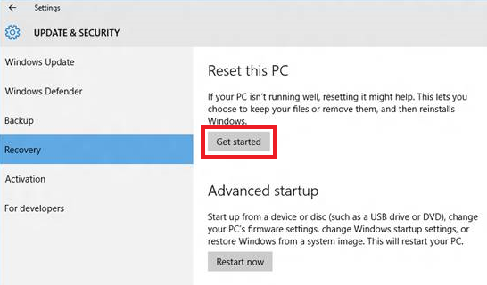

1. The following screen appears:

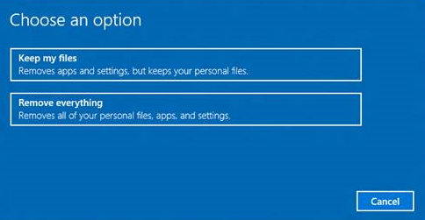

Choose one of these two options:

* **Keep my files.** Keeps your personal data, all user accounts, some customized settings, and any Windows apps and other applications that came with your PC or were deployed by the system administrator. Customizations you have made to applications are not preserved.
* **Remove everything.** Removes all user accounts, personal data, and settings from the Windows partition and reinstalls Windows.

If your PC has more than one hard drive, the following message appears:

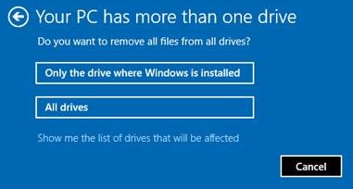

**CAUTION:** Select **Only the drive where Windows is installed** unless you want all drives erased.

# Using Reset when Windows will not start

If Windows will not start, the Windows Recovery Environment launches. The following screen appears:

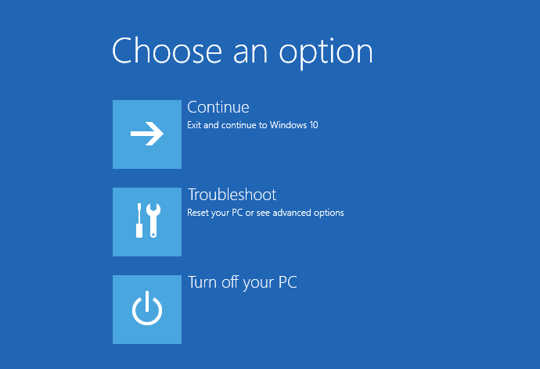

1. Select **Troubleshoot**.
2. Select **Reset this PC**.
3. If BitLocker is enabled, you may be prompted to enter the key.

Select one of the following options:

* **Keep my files.** Keeps your personal data, all user accounts, some customized settings, and any Windows apps and other applications that came with your PC or were deployed by the system administrator.
* **Remove everything.** Removes all user accounts, personal data, and settings from the Windows partition and reinstalls Windows.

If your PC has more than one hard drive, the following message appears:



**CAUTION:** Select **Only the drive where Windows is installed** unless you want all drives erased.

# For more information

For more information about Microsoft products or services, call the Microsoft Sales Information Center at (800) 426-9400. In Canada, call the Microsoft Canada Order Centre at (800) 933-4750. Outside the 50 United States and Canada, please contact your local Microsoft subsidiary. To access information via the web, go to:

<http://www.microsoft.com>

## Windows

<http://windows.microsoft.com>

## Windows 10

<https://www.microsoft.com/en-us/windows/features>

## Reset/Refresh in Windows 10

[http://windows.microsoft.com/en-us/windows-10/refresh-is-part-of-reset-in-windows-10#](http://windows.microsoft.com/en-us/windows-10/refresh-is-part-of-reset-in-windows-10)

## Microsoft IT

<http://www.microsoft.com/ITShowcase>

## For more great productivity guidance, visit…

<http://microsoft.com/ITShowcase/Productivity>

© 2015 Microsoft Corporation. All rights reserved. Microsoft and Windows are either registered trademarks or trademarks of Microsoft Corporation in the United States and/or other countries. The names of actual companies and products mentioned herein may be the trademarks of their respective owners. This document is for informational purposes only. MICROSOFT MAKES NO WARRANTIES, EXPRESS OR IMPLIED, IN THIS SUMMARY.